Section II

Biodesign Innovation Process

1)Biodesign innovation process involves the following steps

* Identification
* Invention
* Implementation

2) Regulatory measures in manufacturing medical device:

* Premarket phase

Premarket notification

Premarket approval 510(k)

* Regulatory submissions, approvals and registrations
* Postmarket phase
* Quality management
* Labelling requirements

The different classes of medical devices based on guidelines from different countries are as follows,

**USA**

|  |  |
| --- | --- |
| Class I | Devices at lower risks.  Example: elastic bandages |
| Class II | Devices with slightly higher risks than class I devices.  Example: Pregnancy testing kits, condoms and powered wheelchairs. |
| Class III | More complex devices.  Example: implantable pacemakers |

**EUROPE**

|  |  |
| --- | --- |
| Class I | Lower risk medical devices( devices that donot have measuring function) |
| Class II | Low /Medium risk |
| Class II a | Medium risk |
| Class II b | Medium /high risk |
| Class III | Medical devices with higher risks |

CHINA

|  |  |
| --- | --- |
| Class I | These devices do not require product tests or clinical trials. |
| Class II | Class II devices require clinical trials |
| Class III | Implanted devices fall under this category where it requires mandated clinical trials. |

INDIA

|  |  |
| --- | --- |
| Class I | Devices with low risk  Example: syringes. |
| Class II | Low – moderate risk  Example: surgical gloves |
| Class III | Moderate – high risk  Example: infusion pumps |
| Class IV | High risk  Examples: Pacemakers and Defibrillators |

3) India is the second most populated country in the world. Lack of health literacy poses a great threat to our nation’s economic stability as healthcare expenditures are on the rise, along with expanding population. As a result of overpopulation, access to quality healthcare and reliable health information can be difficult to come by.

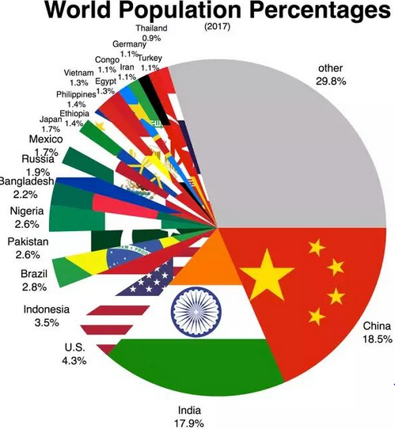

Its not only the general public who suffer from a lack of accurate health information; a report from the World Bank stated, “a detailed survey on the knowledge of medical practitioners for treating five common conditions in Delhi found that the average doctor in a public primary health centre has around a 50-50 chance of recommending a harmful treatment.”

Healthcare system in India can be improved by,

* Improving the infrastructure of the hospitals which could help in providing hygienic treatment to the patients.
* Hiring trained and skilled doctors and nurses, thus improving the efficiency of the treatment process.
* People should be given awareness to prefer for quality treatments rather than going for small, private clinics or hospitals.
* Accessible and affordable nutritious food to people of all sections of society.
* Sanitary facilities and cleanliness has to be ensured by constructing enough toilets and educating people on the need to use them.
* Enough construction of primary health centres in rural areas. These centres must be equipped with resources to serve the purpose.

“University healthcare in no country was achieved overnight”, said K.Srinath Reddy, the President of Public Health Foundation of India”. In some case it has taken several decades; in some cases it has taken a century but you have to begin somewhere”.

If the government invests more on public healthcare, higher wages would attract the doctors and manpower to stay in India. It would help the hospitals to acquire medicines and supplies, receive uninterrupted water and electricity supplies, maintain equipments and ambulances so that they are functional and available any time. With more funding and easy availability of skilled manpower, more healthcare facilities could be opened so that individual centres are not crowded.

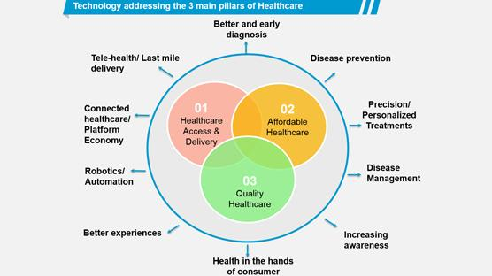

Affordable healthcare through policies and insurance have to be assured by the government and private partners to encourage people Thus the government should provide health insurance to the poor so that they can avail treatment in private hospitals as well. The following actions were recommended by K.Srinath Reddy, President of the Public Health Foundation of India for improving the healthcare system,

Increase health-care spending to 2.5% of GDP : Presently Indian government spends about 1% of its gross domestic product on healthcare, according to the Organisation for Economic Cooperation and Development.

Spend more money on healthcare : It has been stated in a report that over time 70% of public spending should be on primary care.Indian health spending also favors cities over other country sides – urban areas have about four times as many health workers per 10,000 people as rural areas.

Develop an all-India public health service : He also emphazised that to make a national health system that works, more medical and nursing schools will need to be set up and millions more basic healthcare workers will be required, particularly in villages. “We need doctors, we need nurses, we need community health workers,”said Mr.Reddy. “We need a multi-layered health force”